Data Validation Report
Capstone Project Group 1

Team Members:
Sourav Shetty (TL)
Drupad Dev P
Ekta Patil
Sayana Dey
Mayur A

Aim: Validate the given Data and identify the Fact table and Dim table and identify the Joins (Foreign Keys) and understand the star Schema. Generate Extra Records on the Fact table and validate the tables again
Setup: Azure Data Bricks with Pyspark and SQL
Step 1: Identify the given data and understand the Foreign Keys
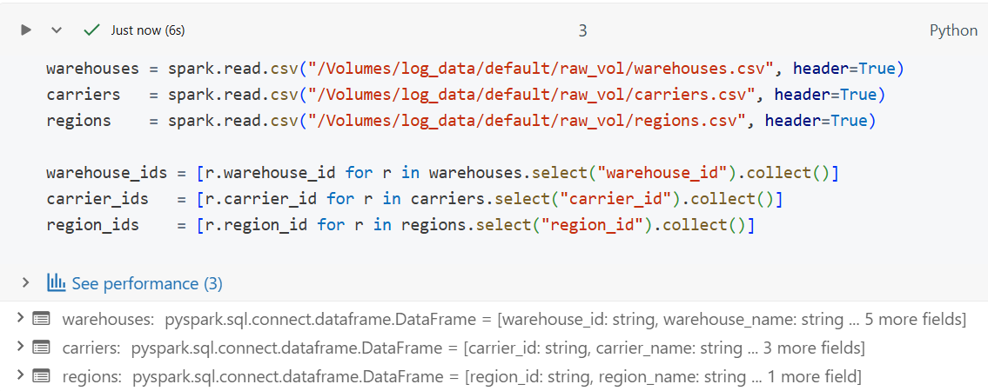
Loading the DIM table data as CSV

Total row Count of the Given data
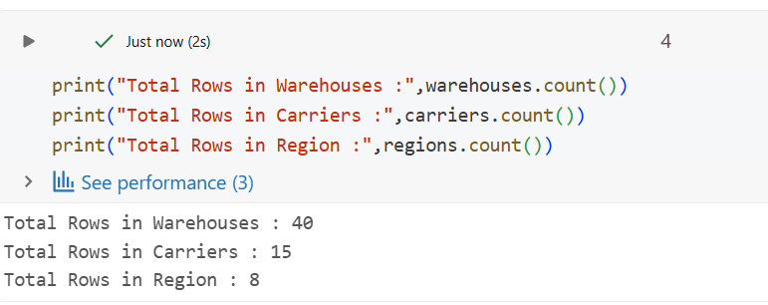
Total No of Rows in the Fact Table before adding generated Data
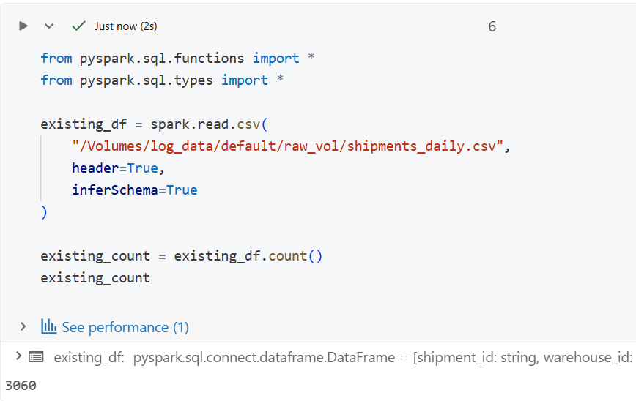

On the Given Data the column delivery_days are Entirely null
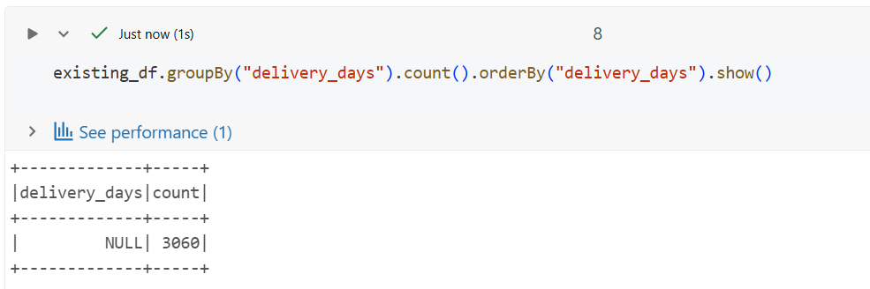
We will handle this condition by giving random days in the newly created data
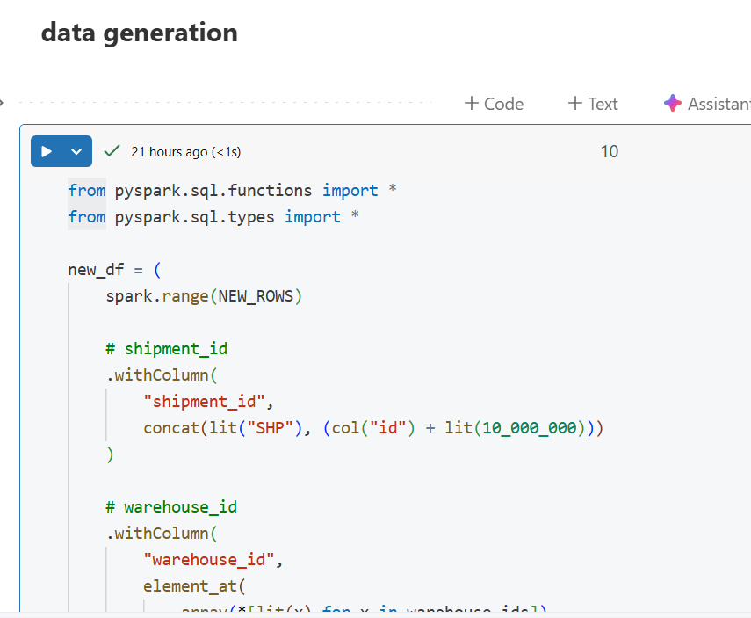

Entire code to Generate New Data into a Spark DF
from pyspark.sql.functions import *
from pyspark.sql.types import *

new_df = (
spark.range(NEW_ROWS)

# shipment_id
.withColumn(
"shipment_id",
concat(lit("SHP"), (col("id") + lit(10_000_000)))
)

# warehouse_id
.withColumn(
"warehouse_id",
element_at(
array(*[lit(x) for x in warehouse_ids]),
((col("id") % len(warehouse_ids)) + 1).cast("int")
)
)

# region_id
.withColumn(
"region_id",
element_at(
array(*[lit(x) for x in region_ids]),
((col("id") % len(region_ids)) + 1).cast("int")
)
)

# carrier_id (allow ~5% NULLs)
.withColumn(
"carrier_id",
when(col("id") % 20 == 0, lit(None))
.otherwise(
element_at(
array(*[lit(x) for x in carrier_ids]),
((col("id") % len(carrier_ids)) + 1).cast("int")
)
)
)

# shipment_cost
.withColumn("shipment_cost", round(rand() * 5000 + 50, 2))

# delivery_status
.withColumn("delivery_status", lit("Delivered"))

# fragile
.withColumn("is_fragile", when(rand() < 0.25, "Y").otherwise("N"))

# shipment_date
.withColumn(
"shipment_date",
date_add(lit("2023-01-01"), ((col("id") % 365).cast("int")))
)

# delivery_days (RANDOM 1–7)
.withColumn(
"delivery_days",
(floor(rand() * 7) + 1).cast("int")
)

# delivery_date (aligned with delivery_days)
.withColumn(
"delivery_date",
date_add(col("shipment_date"), col("delivery_days"))
)

# package weight
.withColumn("package_weight_kg", round(rand() * 50 + 0.5, 2))

# declared value
.withColumn("declared_value_inr", round(rand() * 500000 + 500, 2))

# payment type
.withColumn("payment_type", when(rand() < 0.65, "Prepaid").otherwise("COD"))

# priority
.withColumn(
"priority_level",
when(rand() < 0.5, "Low")
.when(rand() < 0.85, "Medium")
.otherwise("High")
)

# created timestamp
.withColumn("created_ts", current_timestamp())

# DROP Spark-generated ID
.drop("id")
)

Count of New Data generated
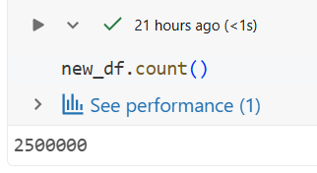
Sample Preview of New Data generated
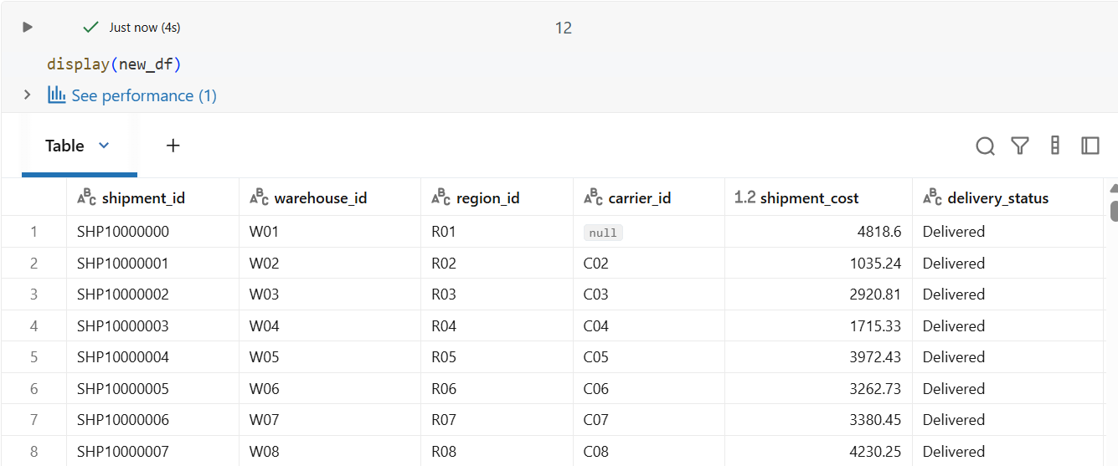
Validating Data
New Columns count is same as old Column
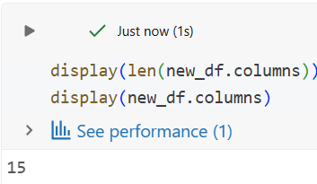

Ensuring Column Matches Exactly
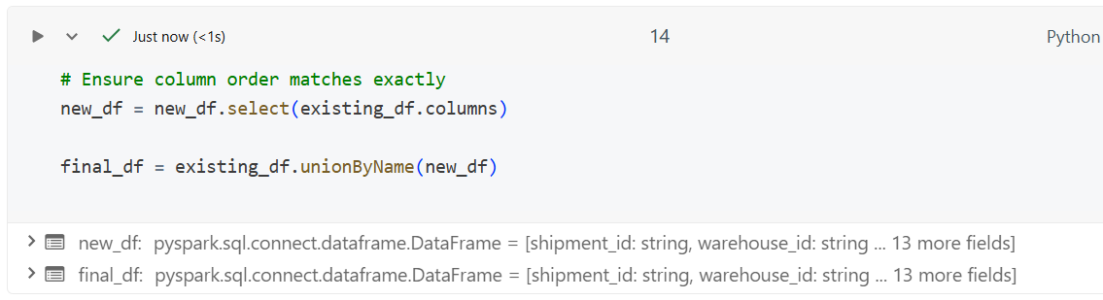
Saving it as new CSV File
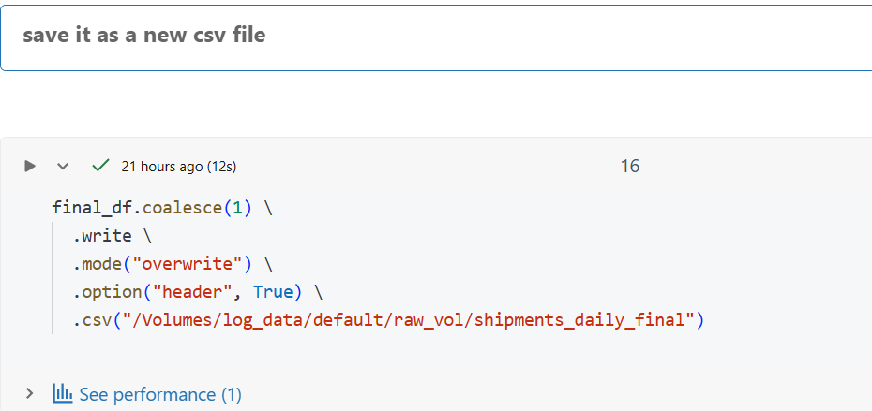
Final row count after adding more data
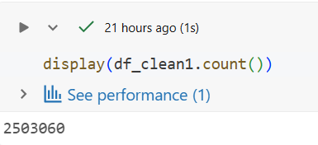

Verifying the newly created data has same count of unique values in the foreign keys
Taking count of Unique values in Foreign Keys
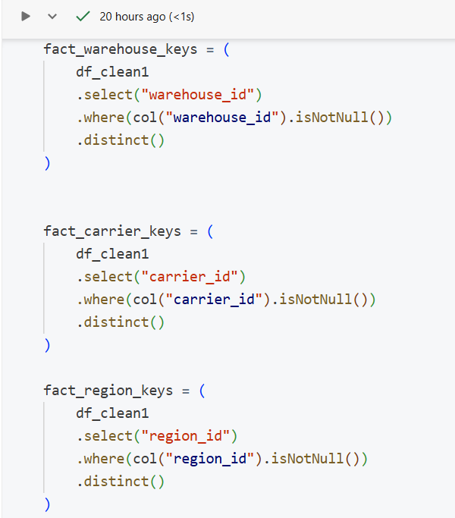

Verifying the Counts of the New Foreign Key Columns
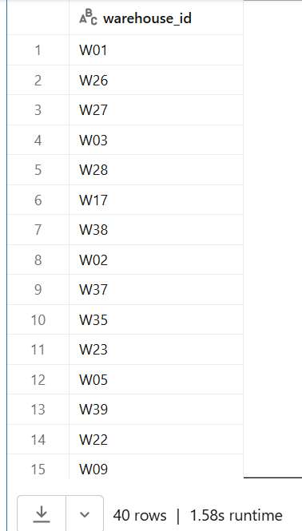 | 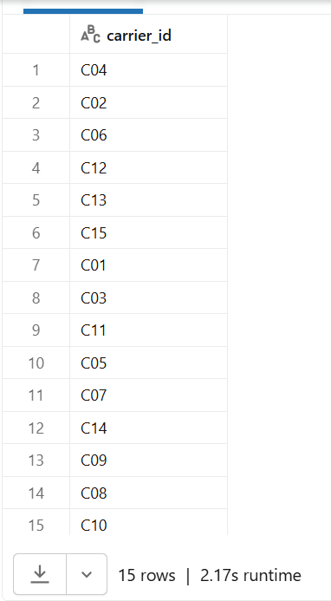 | 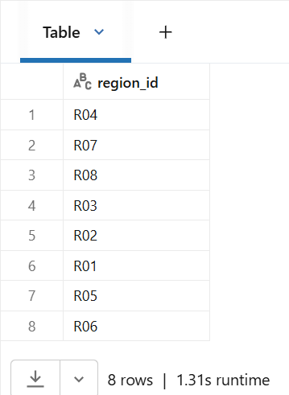

Result:
The old data and the newly Generated data have the same number of Rows saying the new data can be joined without breaking the Schema

